WP Unit 1 Measurement Study Guide – SECTION 1 Name___________________________
- Label the following statements as a (A) Physical Change or (B) Chemical Change
_______ Boiling Water
_______ Decomposing water to H₂ and O₂ gas by passing an electric current through it.
_______ Exploding of potassium metal when place in water
_______ Breaking of glass
_______ Making lemonade (mixing lemons + water + sugar)
_______ Frying eggs
_______ Burning a Candle
_______ Whipping cream
_______ Leaves Changing Color

- Name and describe the three states of matter

- Butane (C₄H₈) is an easily compressible, flammable gas used in cigarette lighters. It has a melting point of -138.4ºC and a boiling point of -0.5ºC. Would you expect a butane lighter to work in winter when the termperature outdoors is -10ºC? Why or why not?

- Hydrogen peroxide, often used to disinfect cuts and scrapes, breaks down to yield water and oxygen
Hydrogen Peroxide water + oxygen
- Identify the reactants and products

- Which of the substances are chemical compounds, and which are elements?

- Describe the general properties of metals, metalloids, and nonmetals:

- Supply the missing names or symbols below:
________ Sodium N ___________________ Hg ____________________
________Chlorine ________ Phosphorous K _____________________
Mo ______________ Cu ____________________ Ag ______________________

- Correct the following statements:
- The symbol for Bromine is BR
- The symbol for Manganese is Mg
- The symbol for Carbon is Ca
- They symbol for Potassium is Po
- What are the units used in the SI system and the Metric System to measure:
Measurement | SI System | Metric System
Mass

Length

Volume

Temperature

SECTION 2:
- Write the symbol for the following units:
- Nanogram ____________
- Microliter ____________
- Milligram ____________
- Micrometer ____________

- Express the following numbers in scientific notation with the correct number of significant figures:
- 9,457 _______________________
- 0.00007 _______________________
- 20,000,000,000 _______________________
- 0.012345 _______________________
- 652.38 _______________________

- Carry out the following calculations, express the answers to the correct numbers of significant, and include units in your answers.
  - 5280 ft/mi X 6.2 mi ______________________________
  - 4.5 m X 3.25 m ______________________________
  - 2.50 g ÷ 8.3 g/cm³ ______________________________
  - 4.70 cm + 6.8 cm – 2.543 cm ______________________________

- Carry out the following conversions. Consult your notebook for conversion standards
  - 3.614 mg to grams a. _____________

  - 56.4 mi to kilometers b. _____________

  - 14.4 μm to millimeters c. _____________

  - 6.03 X 10⁻⁶ cg to nanograms d._____________

  - 2.0 L to quarts e._____________

- The muzzle velocity of a bullet fired from a 9mm handgun is 1200 ft/s.
  - How many miles per hour is this?

  - If the bullet travels 24 ft before it strikes the target, how long will it take the bullet to get there?

- A normal value for blood cholesterol is 200 mg/dL of blood. If a normal adult has a total blood volume of 5L, how much total cholesterol is present?

- To the correct number of significant figures, record the measurement below:
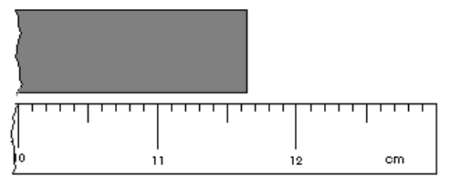
- How many significant figures are in each of the following:
  - 14,397 ___________________
  - 25.6 ___________________
  - 1064 ___________________
  - 10430 ___________________
  - 0.00001 ___________________
  - 0.110 ___________________

