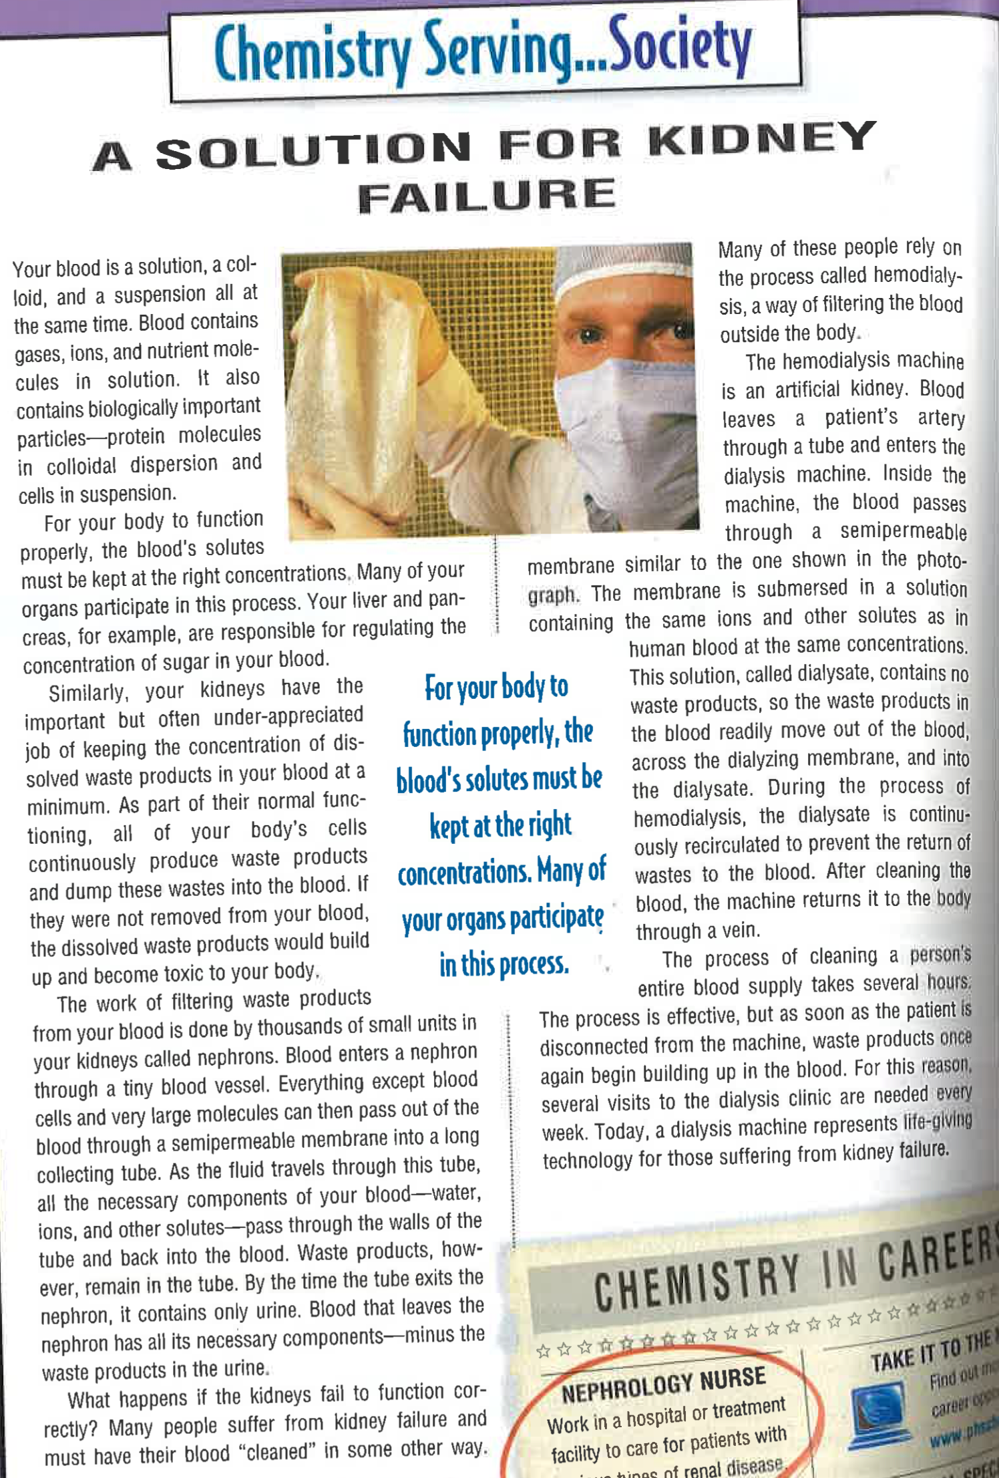

Relevant Article Questions (you may need to look some of these up):

- What is a solution in the context of Chemistry? Be sure to include definitions of Solutes and Solvents.

- What is a buffer? How does it work?

- How does our blood act as a buffer?

- Describe in your own words what pH means.

- Why is it important that your blood can filter materials and act as a buffer to maintain pH?

- What does the term buffer capacity mean?

- Does blood have a high or low buffer capacity?

- What substances in our blood help maintain the effectiveness of the buffer? (i.e. what chemical compounds actually create the buffer(s) present in our blood).

