Fundamentals of Graphing and Analyzing Data

Reading Graphs
Being able to read a graph is a very important skill. Many fields of endeavor, including science, politics, and economics often use graphs to quickly and effectively relate a large amount of information.
Phase Changes of Water

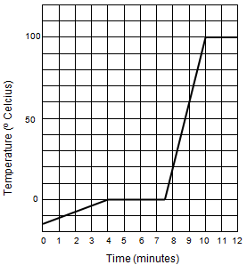
Look at the graph on the right and answer the questions.

- What is the label on the x-axis? The y-axis?

- What units are used to describe these labels?

- Describe in detail what you think the experimenter did to get the data for this graph.

- Over what time interval(s) does the temperature remain constant? Include units.

- Over what time interval(s) is the temperature rising? Include units.

- What is the temperature of the water after four minutes? Include units.

- At what time is the temperature 10ºC?

- If the researcher indicated that the sample was melting between 4 and 7.5 minutes of the experiment, predict what time interval(s) the sample is in the liquid phase.

- In three to four sentences summarize the graphic data. What can you learn from this graph about the properties of water during the phase transitions of melting and boiling?

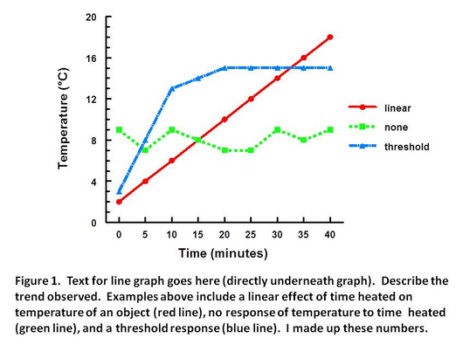
Creating Graphs:
Title Goes Here
All good graphs have several items in common. All good graphs…
- have a title at the top.
- have axes that are labeled, with proper units.
- are neat, and easy to read.
- use most of the available space.
- use legends when more than one data set are presented on the graph

Example Graph to the right:

Graphing Exericise:
Oxygen can be generated by the reaction of Hydrogen Peroxide with Manganese Dioxide

2H₂O₂ + MnO₂ - 2H₂O + Mn + 2O₂

A Chemistry class sets up nine test tubes and placed different masses of MnO₂ in each test tube. An equal amount of H₂O₂ is added to each test tube and the volume of gas produced is measured each minute for five minutes. The data from the experiment is as follows:
Tube # | MnO₂ | 1 min (ml O₂) | 2 min (ml O₂) | 3 min (ml O₂) | 4 min (ml O₂) | 5 min (ml O₂)
1 | 0.1 | 1.4 | 2.6 | 3.5 | 4.2 | 5.1
2 | 0.2 | 2.8 | 4.6 | 5.8 | 7.1 | 7.6
3 | 0.3 | 4.9 | 7.2 | 8.8 | 10.2 | 11.3
4 | 0.4 | 5.9 | 8.5 | 10.4 | 11.8 | 13.3
5 | 0.5 | 8.5 | 12.4 | 14.4 | 16.1 | 17.1
6 | 0.6 | 11.0 | 14.8 | 17.5 | 19.8 | 21.8
7 | 0.7 | 12.0 | 17.0 | 20.2 | 22.7 | 24.8
8 | 0.8 | 13.6 | 19.0 | 22.1 | 24.7 | 27.3
9 | 0.9 | 16.2 | 21.8 | 25.1 | 28.2 | 30.4

1. What volume of O2 did tube #3 produce between the second and fourth minutes?

2. How much O2 is produced in tube #5 during the first two minutes?

3. How much oxygen did tube #7 and #8 produce together during the third minute?

4. What volume of oxygen gas, in liters, was produced during this procedure?

5. Graph the amount of oxygen produced each minute in tubes #2, 4, and 6, using the graph paper below:

6. By comparing the slope of the graph curves, which tube was producing oxygen at the fastest rate between minutes 4 and 5?

Designing Experiments:
When designing an experiment, you need to consider three types of variables. The independent variable is changed by the experimenter in the design. This variable is sometimes called the ‘manipulated variable’. The dependent variable is what changes as a result of the change in the independent variable. This variable is sometimes called the ‘responding variable’. In some cases more than one dependent variable is considered. The third category involves controlled variables. These are varibles that you think might change the outcome of the experiment, but since you are not studying them, you need to keep them constant in each trial.

Read the following experimental design and answer the questions below:
Ethylene is a plant hormone that causes fruit to mature. The data concerns the amount of time it takes for fruit to mature from the time of the first application of ethylene by spraying a field of trees.

Amount of ethylene in ml/m² | Wine Sap Apples:  Days to Maturity | Golden Apples:  Days to Maturity | Gala Apples:  Days to Maturity
10 | 14 | 14 | 15
15 | 12 | 12 | 13
20 | 11 | 9 | 10
25 | 10 | 7 | 9
30 | 8 | 7 | 8
35 | 8 | 7 | 7

1. Make a line graph comparing the data using the graph below. Be sure to give the graph a title and label the x- and y-axis (including the units). Label each line produced to compare the different apple types.

2. What is the dependent variable?

3. What is the independent variable?

4. From the data what conclusions can you make?

5. Farmers constantly need to consider the cost of the products they use. What amount of ethylene would you recommend to the farmer to use? Is it the same for all apple types? Explain your answer.

