**INTRODUCTION**

***Part 1 - Truth in Advertising:*** By law, commercially packaged foodstuffs must be labeled with the weight (mass) or volume of the product contained in the container. Thus, a box of corn flakes labeled 16 oz. must contain 16 oz. of cereal, irrespective of the volume occupied by the product in the container. Settling of the contents may make different boxes of the same product seem to contain diffserent quantities of flakes. We will compare the experimentally obtained masses of a package of a commercial sweetener and a package of cereal with the labeled masses and the experimentally obtained volume of a liquid product with the labeled volume.

Many product manufacturers rely heavily on television advertising to sell their products. These commercials often tout the advantages of their product over that of the competition. Of course, each manufacturer’s product is the best! Most of you are familiar with the television commercial for Bounty papers towels which proclaims Bounty as “the Quicker Picker Upper”. This refers to the speed and effectiveness of Bounty in blotting a liquid spill. We will test the validity of this statement in the laboratory by measuring the absorbency of Bounty relative to some of the competition.

***Part 2 - Density:*** is an important physical property of matter. The density of a substance describes the amount of mass that is contained in a unit volume.

mass

density = _______ (or d = m/v)

volume

High density substances have more mass packed into an equivalent volume than do low density substances. A 1 cm3 sample of water has a mass of 1 g while a 1 cm3 sample of gold has a mass of 19 g. If you compare equal masses of gold and water, the gold will occupy only 1/19 the volume of the water. Since the gold is more dense than water, a gold nugget, when dropped into a container of water, will fall to the bottom of the container. This was a physical property which was very important to the prospectors who panned for gold during the western gold rushes.

**Constructing Graphs and Calculating Density:**

Recall from algebra that any straight line can be described by the general equation

y = mx + b

In this equation, y is the value of the y coordinate, x is the value of the x coordinate, b is the value of the y-intercept (the point at which the line crosses the y axis) and m is the value of the slope. The slope describes the “steepness” of the line, or how rapidly the values of the y variable change relative to the change in the values of the x variable. Slope can be expressed as the following equation:

slope = m = rise = ∆Y

run ∆X

The slope can be determined by choosing two points on the line which are separated by a reasonable distance. Draw a line vertically from the higher point and a line horizontally from the lower point to construct a triangle (see the graph below).

slope = ∆Y = Y2 – Y1 = mass

∆X X2 – X1 volume

Density Example: **Density of Unknown Liquid**



slope = (41.0 g – 11.0 g) = 30.0 g = 0.909 g/mL = Density!

(45.0 mL – 12.0 mL) 33.0 mL

Note: Correct graphs include a Descriptive Title for the graph and the axis must be labeled with the measurement and units! Points will be taken off if these are not included on your graphs.

**Prelab Exercise: Experiment 1**

1. **A student uses a graduated cylinder filled with water and follows the steps of the water displacement method to determine the volume a piece silver.  Below are water levels before and after the piece of silver was added to the graduated cylinder.**
2. 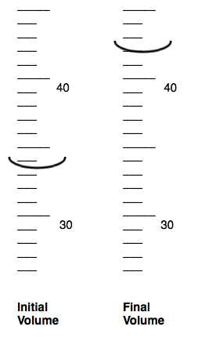**To the proper number of significant figures, what was the initial volume in mL of water in the graduated cylinder before the silver piece was added?**

**________________**

1. **To the proper number of significant figures, what is the final volume in mL of water in the graduated cylinder after the silver piece was added?**

**________________**

1. **To the proper number of significant figures, what is the volume of the silver piece**

**_______________**

*2.* **As the student measures the dimensions of a plastic block and records the following data:**

**Width: 4.53 cm Length: 8.31 cm Height: 2.11 cm**

**Calculate the volume of the block.  Express your answer to the correct number of significant figures**

**_____________________**

*3.* **The length of a piece of string that is less than 46 cm long is measured with the metric ruler depicted.  How many significant figures will be present in the measurement reported as the string's length?**

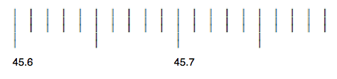 ____________________

*4.* **The water displacement method is used to determine the volume of a chunk of zinc.**

**The following data are recorded:**

**Initial volume of water: 56.43 mL**

**Final volume of water and zinc: 96.79 mL**

**To the proper number of significant figures, what is the volume of the chunk of zinc?**

**________________________**

**5. If the mass of the zinc from question 4, is 288.14 g, calculate to the proper number of significant figures, the density of zinc.**

**________________________**

**6. Use the following graph to calculate how fast the bug is traveling across the rug in cm/s. Show your calculations!**

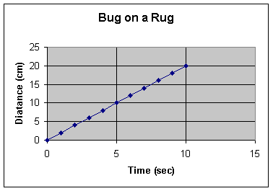

**PROCEDURE (*Be sure to record data on data table in your composition book!)***

**Part I. Truth in Labeling**

**A. Mass Determination of a Commercial Cereal**

1. Place a piece of weighing paper on the pan of the digital balance. Tare the balance by pressing the ON/ZERO/OFF button until the display reads 0.00.
2. Carefully place the *opened* (empty) cereal box on the weighing paper.
3. Record the mass.
4. Repeat the above 3 steps using the *unopened* (full) cereal box.
5. Subtract the weight of the opened package from the weight of the unopened package to determine the mass of product contained in the package. Return the opened and unopened cereal boxes to the bench.

**B. Is Bounty The Quicker Picker Upper??**

1. Look at a small sample of each brand of paper towel under the magnifying glass. Draw the fiber patterns that you observe on the report sheet.
2. Get 1 strip of paper towel from each of the 3 different brands. Carefully draw a line 4 cm from the bottom of each strip.
3. Place approximately 100 ml of water in your 1000-ml beaker.
4. Attach one of the paper towel strips to the pencil with a clip so that the bottom of the strip dips into the water when the pencil is rested across the mouth of the beaker. Record the time it takes for the water to move up to the 4 cm mark.
5. Repeat the procedure with the other brands of paper towels.
6. Graph your results in the form of a bar graph.
7. Dispose of the paper towels in the waste paper cans. *Do not throw paper in the sinks.*

**Part II. Measuring Density**

1. **Density of a Liquid**
2. Record the mass of a dry 100 ml graduated cylinder.
3. Pour about 40 ml of either
   1. water, colored blue ***or***
   2. ethanol, colored red

into a beaker (Only choose one liquid and record which one is used in your lab write up).

1. Pour approximately 5 ml of the liquid into a graduated cylinder. Record the volume to ±0.1 ml (e.g. 5.1 ml). Record the weight of the cylinder containing the liquid.
2. Add another approximately 5 ml portion of the liquid to your graduated cylinder. (You should now have about 10 ml of liquid in the graduated cylinder.) Weigh your cylinder containing this liquid again. Record the total volume and the total weight. Repeat this step until 6 weight/volume readings have been recorded.
3. Return the liquid to the reagent bottle. (This is not a typical laboratory procedure because it can contaminate the original liquid. Today it is acceptable.) Clean and dry the graduated cylinder.

6. Construct a mass versus volume graph for this liquid. Plot the total mass values on the y-axis and the total volumes on the x-axis. Using a ruler, draw the straight line that best fits the points on the graph. Note: each point does *not* have to lie on your straight line—*this is not a connect-the-dots exercise*. The density of the liquid is obtained from the slope of the straight line as described on the page following the lab procedures.

**D The Tale of Two Soft Drinks**

1. Observe the demonstration in the front of the lab. An unopened can of regular Pepsi and another of diet Pepsi have been placed in an aquarium filled with water. Record your observations.
2. Weigh both the unopened and pre-opened cans of regular and diet soft drinks in the balance room. Record these weights.
3. Determine the approximate density of each type of soft drink.

**TRUTH IN LABELING AND ADVERTISING**

**PART I. Truth in Labeling**

1. Cereal: mass stated on label ______________

unopened package mass ______________

opened package mass ______________

product mass ______________

Compare stated vs. calculated mass:

**B. Paper Towel Absorbancy: Is Bounty the Quicker Picker Upper?**

fiber patterns

Brand:

Brand:

Brand:

**Paper Towel Data:**

|  |  |
| --- | --- |
| **Paper Towel** | **Time (seconds)** |
|  |  |
|  |  |
|  |  |

Graph: When you are graphing data, you need to be sure to include a descriptive title and axis labels, including measurement units. The known or constant units should be placed on the X-axis and the variable or measured units on the Y-axis.

**Paper Towel Absorbancy Test**



**Type of Paper Towel**

Is Bounty really the “Quicker Picker Upper”? Explain your conclusion.

How do the paper towel fiber patterns correlate with the absorbency of the paper towel?

**Part II: MEASUREMENT OF DENSITY**

**Part C. Density of a Liquid**

Identity of liquid: _________________________

Mass of empty graduated cylinder: _____________________

Column A Column B Column C Column D

|  |  |  |  |  |
| --- | --- | --- | --- | --- |
|  | total mass  cylinder + liquid | mass of empty cylinder | total mass  liquid (Column A-B) | total volume  liquid |
| 1 |  |  |  |  |
| 2 |  |  |  |  |
| 3 |  |  |  |  |
| 4 |  |  |  |  |
| 5 |  |  |  |  |
| 6 |  |  |  |  |



Calculate the Density of the Liquid from the Slope of the Best Fit Line in the Graph Above:

Density of liquid: _______________________________

**p**

**Part D. The Tale of Two Soft Drinks**

Observation of soft drink cans in water:

|  |  |
| --- | --- |
| mass of diet drink + can |  |
| mass of empty diet can |  |
| mass of diet drink - can (calculate) |  |
| Volume of diet drink (from label) |  |

|  |  |
| --- | --- |
| mass of regular drink + can |  |
| mass of empty regular can |  |
| mass of regular drink - can (calculate) |  |
| volume of regular drink (from label) |  |

|  |  |
| --- | --- |
| density of diet drink (g/mL) |  |
| density of regular drink (g/mL) |  |

**Conclusions:**

Do the measured densities of the soft drinks explain your observation of the behavior of the two cans in water? Explain your conclusion.

**TEACHERS NOTES: Experiment 1 Truth and Density**

For 45 min classes, we recommend breaking this lab down into two periods. Complete Parts A and B on Day 1 and Parts C and D on Day 2. Note: The PreLab Assignment should be given as homework at least the night before the lab is to be performed and the student should turn the assignment in at the beginning of class, prior to beginning the lab.

(For a class of 24 students working in pairs)

**Materials**

**Station A. (Have student pairs rotate through this station during the class time. They can work on part B while waiting to make measurements for part A)**

* 3 sets of the following will be needed:
* One serving size cereal box full (ie Travel size cereal box)
* One serving size cereal box and material, no cereal inside
* Digital balance (2-3)

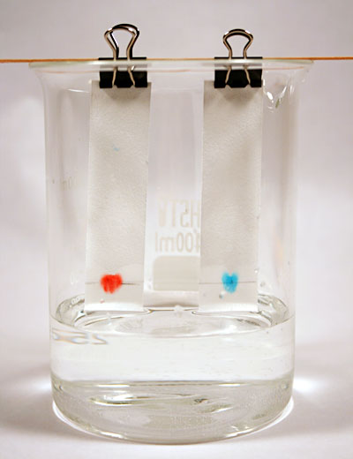**Station B. (Take back to desk)**

* 12 sets of the following will be needed:
* 5 x 10 cm paper towel strips of each brand (dimensions depend on beakers used. We recommend setting one up as a demonstration model – similar to the chromatography photo shown at the right)
* 100mL of H20
* 1000mL beaker
* Pencil
* Paper clip
* Stopwatch

**Station C.**

* 100mL graduated cylinder
* 40mL of water or 40ml of ethanol*
* Blue and Red color dye (food coloring)
* Ruler

*Note: Ethanol can be reused. Have the students carefully pour it back into the stock bottle (but tell them that this is not normally done!)

**Station D.**

* 1 pre-opened, empty can and 1 unopened can of Regular Pepsi
* 1 pre-opened, empty can and 1 unopened can of Diet Pepsi